

Remembrance Day Service & Parade
Sunday 10th November 2024

Service commences at 10.00am
Holy Trinity Church
followed by a parade to the

War Memorial

A two-minute silence will be observed followed by wreath laying and a short service

The Baptist Church extends a very warm welcome to everyone for refreshments following the service

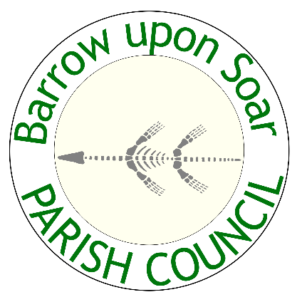
A road closure will be in operation throughout the morning

